**Progress Report for 25 August 2015**

* Extracted relevant data channels (T7, T8, P7, P8, AF3, AF4, F3, F4) from 1v1 physical recording data, performed band-pass filter, computed cross-correlations between single-channel data:

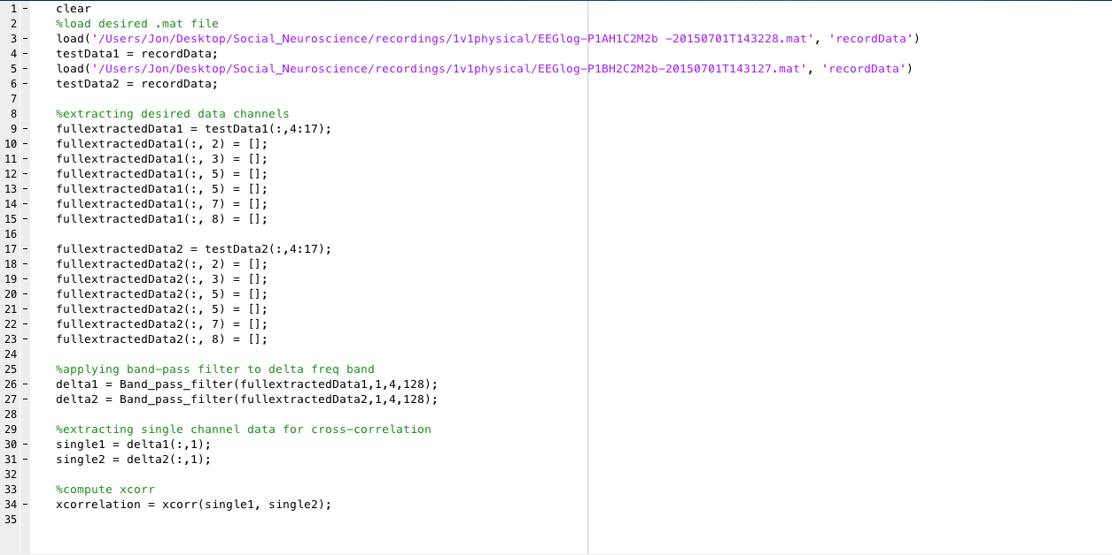

* Sample EEG data (EEGlog-P1AH1C2M2b -20150701T143228.mat) for reference:

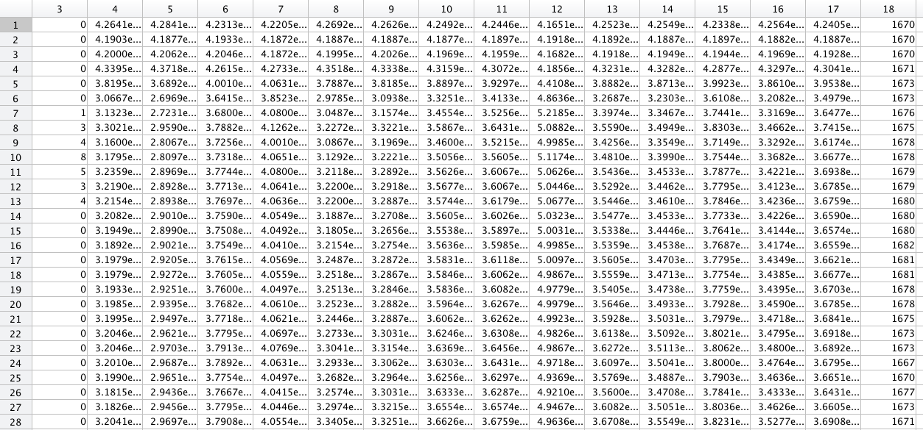

* Band-pass filter function:

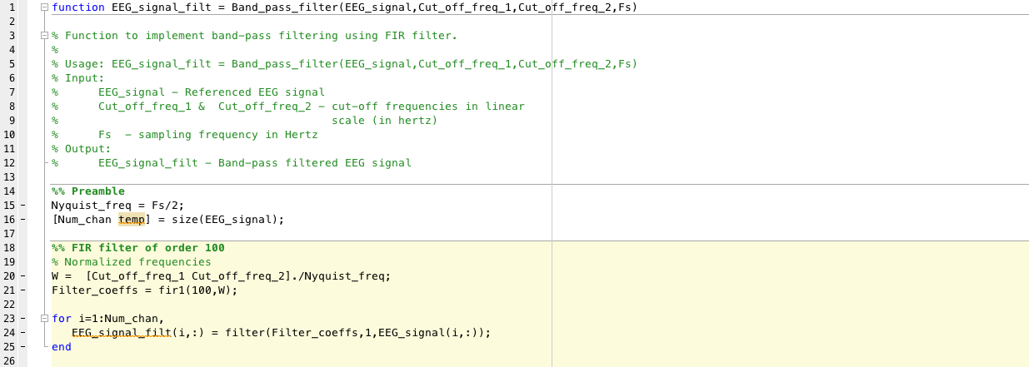

* Cross-correlation results:

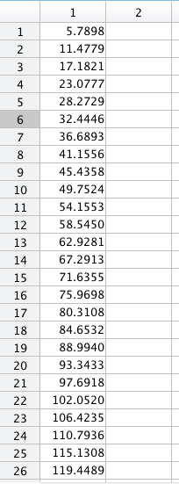

**Comments:**

1. Cross-correlation results do not correspond with expected range of [-1,1]. Need to identify sources of error in presented code and/or data.
2. Compilation time is fairly significant: Between 5 to 10s for current code presented above.
3. Data extraction code may be further condensed and called in functions.